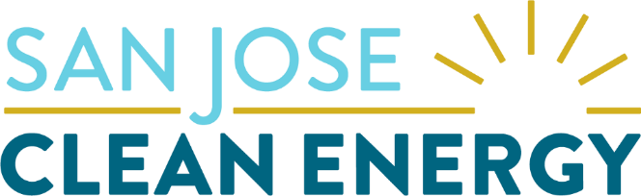

Ava Community Energy / San José Clean Energy

2024 Long-Term Resource

Request for Offers

**Attachment A: Notice of Intent to Offer**

This Notice of Intent to Offer (“NOI”) shall serve as notice to Ava Community Energy (Ava) and San José Clean Energy (SJCE) (together, the “CCAs”) that the company listed below intends to participate as a seller (“Respondent”) in the CCAs’ 2024 Long-Term Resource Request for Offers. Only Respondents that have submitted a valid NOI will be provided a Dropbox submission folder link required to submit all documents in compliance with the RFO protocol.

Ava & SJCE require that the Respondent return the NOI by 2 PM PPT on October 2, 2024; earlier submission is welcomed and appreciated. Ava/SJCE will provide a submission folder link within two business days of NOI return. The NOI must submitted by email to [2024-RFO@avaenergy.org](mailto:2024-RFO@avaenergy.org) with the subject line of: “NOI: Renewable Energy & Storage RFO – [*RespondentCompanyName*].”

Please save the file with the name: “Ava-SJCE NOI*_RespondentCompanyName*”.

**Contact Information:**

|  |  |
| --- | --- |
| Company Name |  |
| Respondent Primary Contact Name |  |
| Respondent Primary Contact Title |  |
| Respondent Primary Contact Email |  |
| Respondent Primary Contact Phone |  |
| Respondent Secondary Contact Name |  |
| Respondent Secondary Contact Title |  |
| Respondent Secondary Contact Email |  |
| Respondent Secondary Contact Phone |  |

*(on the next page, please indicate Respondent’s initial plan for Offers)*

**Initial Plan for Offers:**

Using the following numbering system for the different acceptable products, complete the table below:

1. As-Available Product from RPS-eligible resources
2. As-Available RPS Product plus Energy Storage
3. Indexed Energy plus RPS attributes
4. Shaped RPS Energy Product
5. Tranche 2 Product

|  |  |  |  |  |
| --- | --- | --- | --- | --- |
|  | **Product Code(s)** | **Technology** | **Location:**  **“Y” if**  **Alameda County** | **Location:**  **“Y” if**  **Out of State** |
| **Project 1** |  |  |  |  |
| **Project 2** |  |  |  |  |
| **Project 3** |  |  |  |  |
| **Project 4** |  |  |  |  |
| **Project 5** |  |  |  |  |
| **Project 6** |  |  |  |  |

*The chart above is intended to provide an indicative sense of projects Ava/SJCE will see. Respondent is not required to submit Offers that match the above chart.*