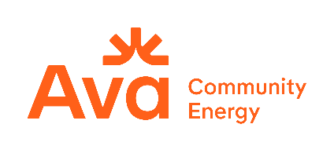

Ava Community Energy
Disadvantaged Communities Green Tariff
Request for Offers

Attachment A: Notice of Intent to Offer

ATTACHMENT A: NOTICE OF INTENT TO OFFER This Notice of Intent to Offer (“NOI”) shall serve as notice to Ava Community Energy (Ava) that the company listed below intends to participate as a seller (“Respondent”) in Ava’s Disadvantaged Community Green Tariff Request for Offers. Only Respondents that have submitted a valid NOI will be provided a Dropbox submission folder link required to submit all documents in compliance with the RFO protocol.

The NOI must be submitted by email to 2026dacrfo@avaenergy.org with the subject line of: “NOI: Disadvantaged Community RFO – [RespondentCompanyName].” Please save the file with the name: “Ava NOI_RespondentCompanyName”.

Enter contact Information for up to two contacts:
Company Name
Respondent Primary Contact Name
Respondent Primary Contact Title
Respondent Primary Contact Email
Respondent Primary Contact Phone
Respondent Secondary Contact Name
Respondent Secondary Contact Title
Respondent Secondary Contact Email
Respondent Secondary Contact Phone

