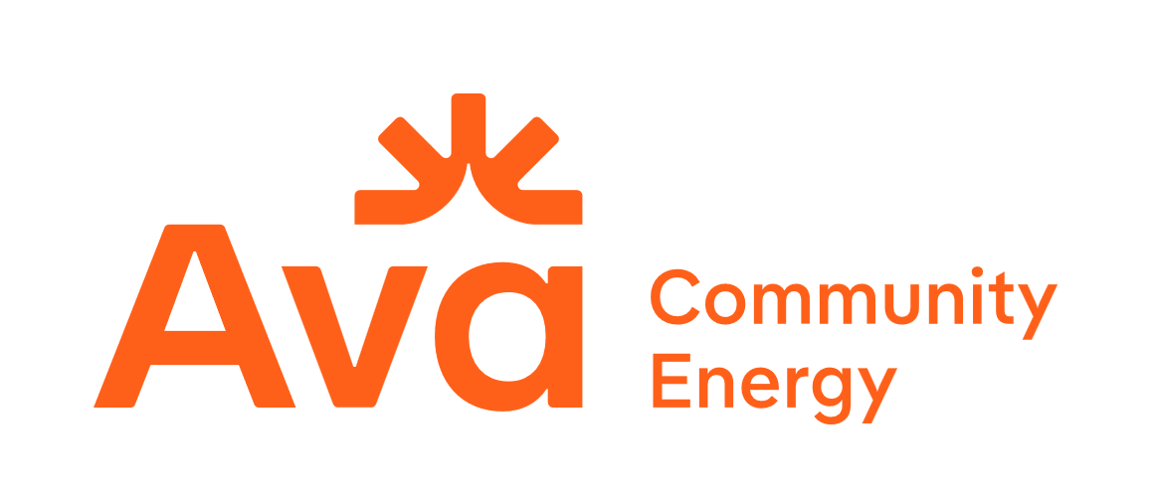

Ava Community Energy
2026 Disadvantaged Communities Green Tariff
Request for Offers

Attachment C: Project Narrative Template

Instructions

Respondents should submit a brief narrative of the proposed project and vendor qualifications. This narrative will be primarily used as a reference for specific project details that are not fully captured in the Offer Form templates and for further assessment of proposals.

The project narrative must include the following sections in the order listed below. Further instructions for each section are provided below. Please limit the project narrative to five pages or less.

- Corporate Structure
  - Briefly describe the history of the company’s operation, size and footprint of the company, including reference to the number of personnel based in California and in the Ava service territory.
  - Briefly describe the company’s corporate financing structure, noting access to capital and latest bond rating (if applicable). Additionally, include the same information for any Project Owner other than the Respondent company, referencing the project(s) in which they have an ownership stake.
  - Provide any additional relevant information regarding the Respondent’s company and/or company structure that is influential to the Respondent’s ability to execute their Offer(s).

- Development Experience
  - List all operational projects, including details on: (a) location, (b) size, (c) technology, (d) COD date, (e) offtaker, (f) any other pertinent details. Please denote which projects, if any, are executed with CCAs.
  - List all projects that have executed PPAs and are pre-COD, including details on: (a) location, (b) size, (c) technology, (d) anticipated COD, (e) current project status, (f) offtaker, if public. Please denote which projects, if any, are executed with CCAs.

- Project Financing and Ownership
  - Describe the financing strategy related to development, construction, and long-term ownership. Please state your assumptions relative to the project financing structure, the type of anticipated/committed financing, and all involved parties.
  - Describe how development costs have been financed to date.
  - Describe the long-term ownership plan for the asset.
  - Provide historical track record on completed financings and partnerships

- Project Summary
  - Brief summary of project including location, size, technology description, and any relevant high-level details.
  - Explicitly list all Offers being made from this facility, organized by product, referencing each Offer using the naming convention: SiteName_ProductNumber-OfferNumber.
Note: The product number should correspond with the one of the products listed in the protocol and the Offer Number should correspond with the numbering on the relevant Offer Form tabs.
  - Would Ava be the sole offtaker of products from the site proposed? If there are other known or potential offtakers, please detail their contracting status to give Ava a better sense of the execution plan and risks.

- Project Details
  - Include project name, location city and county, census tract, census tract DAC classification and DAC designation (3.0, 4.0) if applicable, capacity size, energy sizing (duration), COD, and pricing ($/kWh and $/kW-month)
  - Describe site control for the project, clearly stating the current status, key risks, and whether or not Respondent has site control for the full duration of the term offered.
  - Describe the status of the project’s interconnection, including location, expected configuration, key risks, results of latest Phase I/Phase II Study or Facilities Study, estimated interconnection facility and upgrade costs.
  - Describe the status and risks associated with zoning, permitting and environmental impact.
  - Describe the status and risks associated with supply chain.
- Project Site Description
  - Detailed description of the current land use of the project footprint, including a detailed site map including DAC designation and borders.
  - Describe the project’s proposed interconnection, including proximity to transmission or distribution interconnection and any new interconnection facilities that would need to be built.
- Community Experience
  - Describe what benefits the project provides the community in which it is located, including Ava member agency partnership or co-investment, and grant eligibility.
  - Describe completed or planned community outreach and communications strategy.
  - Describe bidder’s previous experience in community engagement, either in the community in which the project is located, or others.
- Workforce Development Plan
  - Description of how workforce development and job training will be incorporated into project development efforts, including how the project meets the Workforce Development Plan evaluation criteria described in Section 4: Evaluation Criteria and Selection Process.
  - State which labor strategy the project will use:
    - Multi-trade project labor agreement (PLA)
    - No PLA, but will pay prevailing hourly wage and benefit rates as determined by the California Department of Industrial Relations
    - None of the above
  - Describe the project’s labor strategy and commitments, including details on:
    - PLAs that incorporate Local and Targeted Hire objectives as follows:
- A goal of 30% of all project labor hours performed by Local Hires.
- Participation in a Targeted Hire Program with a goal of 10% of all project hours performed by Equity Priority Workers.
- Demonstrated commitment to subcontracting with Small, Local, and Emerging Businesses.
    - Where a PLA will not be used:
      - Utilization of prevailing hourly wage and benefit rates as determined by the California Department of Industrial Relations.
      - Utilization of apprentices at the same ratio of apprentice hours to journeyperson hours as required for public works projects. Generally, this is one apprentice hour per every 5 hours of journeywork per craft.
      - Demonstrated commitment to Local and Targeted Hire, including utilization of a multi-craft core curriculum (MC3) pre-apprenticeship program, or equivalent industry and state recognized pre-apprenticeship certification, for outreach, preparation, support and referral of Targeted Hires.
      - Demonstrated commitment to subcontracting with Small, Local, and Emerging Businesses.
    - Percentage of contractors or sub-contractors based in project county.
    - Percentage of contractors or sub-contractors based in Ava service territory.
    - Number of contractors or sub-contractors certified as small businesses (either state or federal certification).
    - Commitments to workforce development opportunities (either directly through the project or through investment in workforce development opportunities elsewhere).

- Offer Variants
  - Description of additional variants the Respondent would like Ava to consider.
  - If the Seller would like to propose offer variants beyond the one proposed in the Offer Form Template, these variants may be described in text in this section. These additional variants may not be submitted as offer form templates and will not be evaluated in the quantitative evaluation phase but may be assessed for additive value if the initial proposal is chosen for shortlisting consideration.
    - Alternative offers that might be proposed in this section include distinct CODs, alternative pricing schemes, or any other arrangements that may provide additional value.

