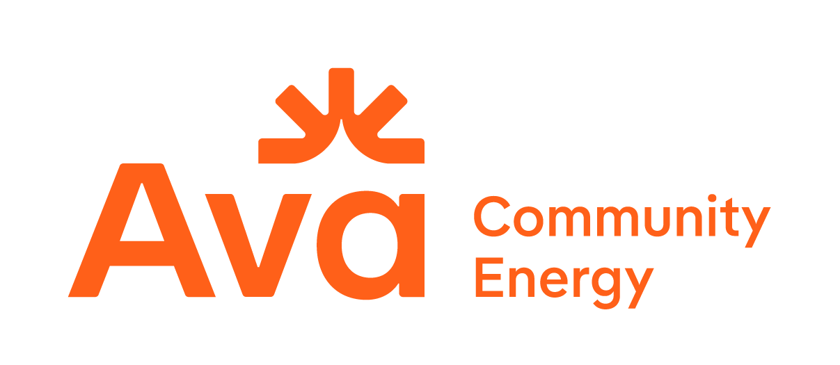


Ava Community Energy / San José Clean Energy
2026 Long-Term Resource
Request for Offers
Attachment A: Notice of Intent to Offer

This Notice of Intent to Offer (“NOI”) shall serve as notice to Ava Community Energy (Ava) and San José Clean Energy (SJCE) (together, the “CCAs”) that the company listed below intends to participate as a seller (“Respondent”) in the CCAs’ 2026 Long-Term Resource Request for Offers. Only Respondents that have submitted a valid NOI will be provided a Dropbox submission folder link required to submit all documents in compliance with the RFO protocol.
Ava & SJCE require that the Respondent return the NOI by 2 PM PPT on June 17, 2026; earlier submission is welcomed and appreciated. Ava/SJCE will provide a submission folder link within two business days of NOI return. The NOI must submitted by email to 2026RFO@avaenergy.org with the subject line of: “NOI: Renewable Energy & Storage RFO – [RespondentCompanyName].”
Please save the file with the name: “Ava-SJCE NOI_RespondentCompanyName”.

Contact Information:
Company Name

Respondent Primary Contact Name

Respondent Primary Contact Title

Respondent Primary Contact Email

Respondent Primary Contact Phone

Respondent Secondary Contact Name

Respondent Secondary Contact Title

Respondent Secondary Contact Email

Respondent Secondary Contact Phone

(on the next page, please indicate Respondent’s initial plan for Offers)
Initial Plan for Offers:

Using the following numbering system for the different acceptable products, complete the table below:
- As-Available Product from RPS-eligible resources
- As-Available RPS Product plus Energy Storage
- Firm or Shaped RPS Product
- Stand-Alone Energy Storage Toll
- Tranche 2 Product

 | Product Code(s) | Technology | Location:  “Y” if  Alameda County | Location:  “Y” if  Out of State
Project 1
Project 2
Project 3
Project 4
Project 5
Project 6

The chart above is intended to provide an indicative sense of projects Ava/SJCE will see. Respondent is not required to submit Offers that match the above chart.

